

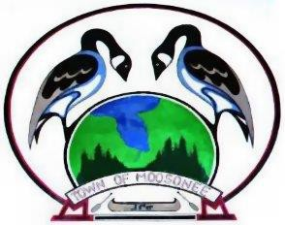
The Corporation of the
Town of Moosonee
P.O. Box 727, 5 First Street Moosonee, Ontario P0L 1Y0
TEL: (705) 336-2993 FAX: (705) 336-2426
Touch the Edge of the Arctic! www.moosonee.ca

PUBLIC NOTICE

SPECIAL MEETING

Monday, June 22nd, 2026
@ 6:00pm
Town Administration Office
5 First Street

Topics

Public Meeting

2026 Operating Budget

