

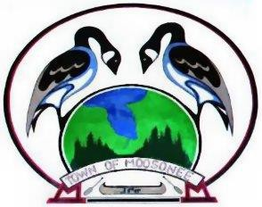
The Corporation of the
Town of Moosonee
P.O. Box 727, 5 First Street Moosonee, Ontario P0L 1Y0
TEL: (705) 336-2993 FAX: (705) 336-2426
Touch the Edge of the Arctic! www.moosonee.ca

PUBLIC NOTICE

SPECIAL MEETING

Friday, December 19th, 2025
@ 4:30pm
Town Administration Office
5 First Street

Topics

OPEN SESSION MEETING
- To confirm the First Quarter Council Meeting Dates for 2026.
- Briefing Note Radiator Purchase for Generator

CLOSED SESSION MEETING
→ Personal matters about an identifiable individual, including municipal employees
→ A Position, plan, procedure, criteria, or instruction to be applied to negotiations

