**NOTICE OF INTENT TO CONSIDER THE REMOVAL OF A HOLDING SYMBOL**

**FROM THE ZONING BY-LAW**

**THE CORPORATION OF THE TOWN OF MOOSONEE**

**PLEASE TAKE NOTICE** that The Corporation of the Town of Moosonee is considering an amendment to the Town’s Zoning By-law (Town File No. ZBA 2025-03) pursuant to Section 36 of the Planning Act, R.S.O. 1990, Chapter p. 13, as amended. The application applies to the subject lands located on Percy’s Way and are locally known as the Hospital Project Lands. Please refer to the Key Map in this Notice for the location of the subject lands.

The application has been submitted by Horizon North and Catering Partnership on behalf of the Weeneebayko Area Health Authority (WAHA). The purpose and effect of the application is to remove the Holding (H) symbol from a portion of the subject lands, which are currently zoned the Institutional Exception 2 Holding (I-2-H) Zone and the Institutional Exception 2 (I-2) Zone. The applicants are proposing a temporary worker camp on a portion of the subject lands. The purpose of the Holding Symbol is to ensure the following matters have been adequately addressed:

1. Owner/Applicant has entered into a Site Plan Control Agreement with the Town;
2. Owner/Applicant has entered into an agreement with the Town to satisfy off-site infrastructure requirements and cost recovery (or addressed this matter through a Functional Servicing Report); and,
3. Owner/Applicant has demonstrated that the proposed development can be appropriately serviced.

# DATE AND LOCATION OF PUBLIC MEETING

Date: May 27, 2025

Time: 5:30 p.m.

Location: Town Council Chambers, 5 First Street, Moosonee, ON P0L 1Y0

The earliest date that Council can meet to pass the Removal of the Holding Symbol By-law is the date listed above. Should you desire to provide comments, you may submit verbal or written comments to the Planning Coordinator in advance of the Council meeting. Please provide written comments by May 26, 2025. Verbal comments will be transcribed and presented at the Council meeting.

# ADDITIONAL INFORMATION AND MAP OF LAND SUBJECT TO THE APPLICATION

Additional information regarding the application is available for review at the Town office during normal business hours. Please contact the Planning Coordinator to arrange to review this file.

If you wish to be notified of the decision of the Council for The Corporation of the Town of Moosonee with respect to the proposed application, you must submit a written request (with forwarding addresses) to the Planning Coordinator of the Town of Moosonee at the Town Office located at 5 First Street, Moosonee, Ontario, P0L 1Y0. It is suggested that written comments be dropped off at the Town Office.

Boblin Jardino, Planning Coordinator

The Corporation of the Town of Moosonee

PO Box 727, 5 First Street, Moosonee, Ontario P0L 1Y0

Phone: 705-336-2556

Fax:  705-336-2581

Email: [planningcoordinator@moosonee.ca](mailto:planningcoordinator@moosonee.ca)

May 16, 2025

**KEY MAP OF THE SUBJECT LANDS**

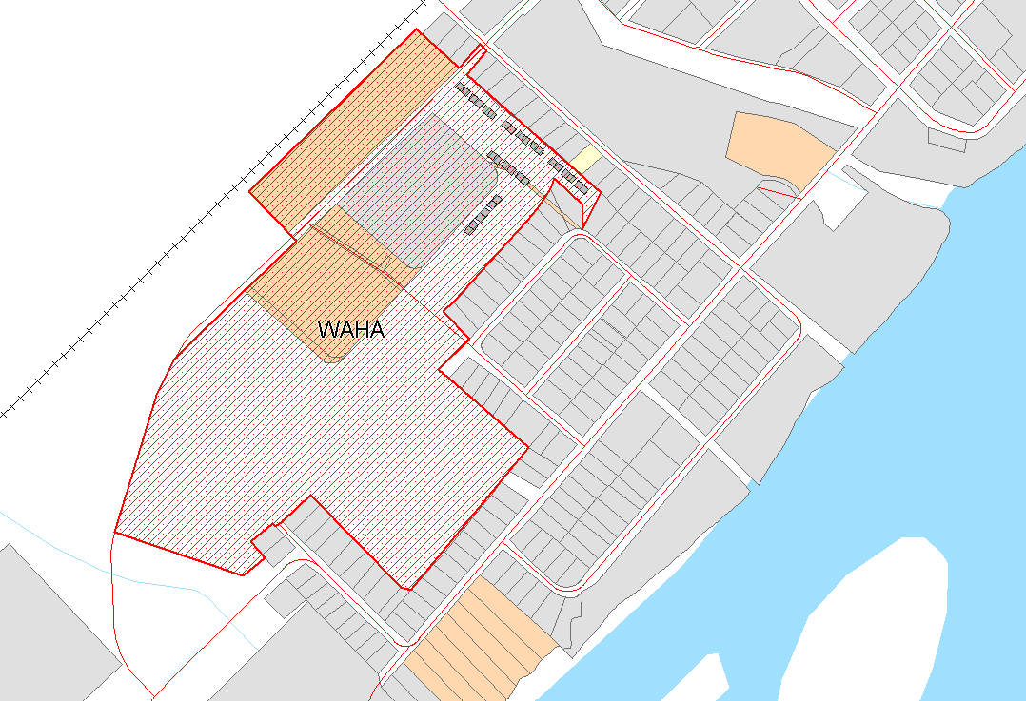

LANDS FOR THE ‘H’ SYMBOL TO BE REMOVED

SUBJECT LANDS