The Corporation of the Town of Moosonee

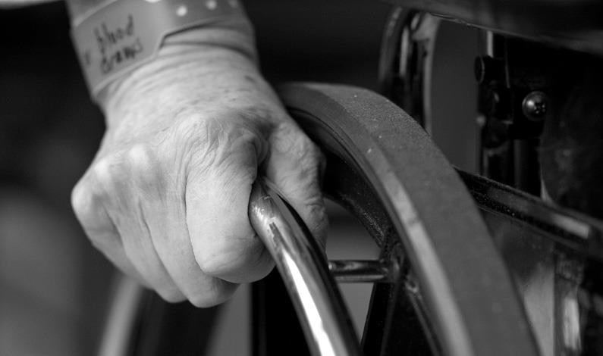Accessibility & Action Plan

Adopted by Moosonee Town Council on June 2015

Originally Adopted by Council on October 19th, 2009
- Reviewed – December 2010
- Reviewed – December 2011
- Reviewed – December 2012
- Reviewed – December 2013
- Reviewed – December 2014

Five Year Review – 2015
Re-Adopted by Council Jube 2015
- Reviewed - December 2021

EXECUTIVE SUMMARY

The purpose of the Ontarians with Disabilities Act, 2001 (ODA) is to improve access and opportunities for people with disabilities and to provide for their involvement in identifying, removing and preventing barriers. The ODA mandates municipalities to prepare an Accessibility Plan. The Accessibility for Ontarians with Disabilities Act, 2005 (AODA) reinforces the requirements of developing and enforcing of accessibility standards by all organizations over the next 20 years. A full range of disabilities are addressed by the new Act including physical, sensory, mental health development and learning.
The Accessibility Plan for the Town of Moosonee will describe the action taken – past, present and proposed – to identify, remove and prevent barriers in the facilities and services offered by the municipality. The Town of Moosonee is committed to providing its residents with accessible facilities and services.

OBJECTIVES

The Town of Moosonee is committed to identifying barriers, making recommendations, and taking measures to assist those persons with disabilities to use the facilities and services offered by the municipality. The Town of Moosonee is committed to comply with the ODA and AODA standards by the Year 2025, and will establish goals on an annual basis to achieve full compliance.

REVIEW AND MONITORING THE PROCESS

The Town of Moosonee’s Accessibility Plan will be reviewed and updated annually. Additional barriers will be identified and further recommendations will be made to Council. Town policies, bylaws, programs and services will continue to be reviewed, monitored and added.

ACTION PLAN – BARRIER IDENTIFICATION

LOCATION & BARRIER | BARRIER TYPE | RECOMMENDATION | TIMELINE
Town Hall | Architectural & Physical | - Automatic Doors are required to facilitate ease of wheelchair access  - Designated Accessible Parking | - 5 year Capital Planning  - COMPLETE
Town Website | Technological | - Website Accessibility - Comply with WCAG  2.0 legislation | - COMPLETE
Town Hall | EMPLOYMENT  – Architectural & Physical | - Automatic Doors are required to facilitate ease of wheelchair access  - Other barriers as may be identified by employees with a disability | - Apply Individual Accommodation Plan Policy to develop a plan to accommodate the employment of employees with a disability.
Accessibility Plan & Policies | Communication | - Develop Accessibility Plan, By-Law and Policies – review annually | - COMPLETE
Sensitivity Training for Employees | Attitudinal | - Training to be undertaken by all Town Employees – orientation & on-going | - COMPLETE & ON- GOING
Paved Roadways and Sidewalks | Architectural & Physical | - Pavement will improve accessibility for those in wheelchairs | - Dependent on government funding
Arena & Fitness Centre | Architectural & Physical | - Wheelchair Access at stairs  - Automatic Doors are required to facilitate ease of wheelchair access  - Designated Accessible Parking  - Designated Accessible Washrooms | - COMPLETE  - 5 year Capital Planning  - COMPLETE  - 5 year Capital Planning
Arena & Fitness Centre | EMPLOYMENT  – Architectural & Physical | - Automatic Doors are required to facilitate ease of wheelchair access  - Public Washroom to be made wheelchair accessible  - Other barriers as may be identified by employees with a disability | - Apply Individual Accommodation Plan Policy to develop a plan to accommodate the employment of employees with a disability.

Municipal Marina | Architectural & Physical | - Modified slope and surface to access the docks from the roadway, to improve safety. | - 5 year Capital Planning – Partially complete
Airport | Architectural & Physical | - Wheelchair Access at stairs  - Automatic Doors are required to facilitate ease of wheelchair access  - Designated Accessible Parking  - Designated Accessible Washrooms | - 5 year Capital Planning  - 5 year Capital Planning  - COMPLETE  - 5 year Capital Planning
Airport | EMPLOYMENT  – Architectural & Physical | - Automatic Doors are required to facilitate ease of wheelchair access  - Public Washroom to be made wheelchair accessible  - Other barriers as may be identified by employees with a disability | - Apply Individual Accommodation Plan Policy to develop a plan to accommodate the employment of employees with a disability.
Fire Hall | EMPLOYMENT  – Architectural & Physical | - Designated Accessible Washroom or alter current Washroom to accommodate (not a public building)  - Access to second & third floors would require an elevator installation  - New Fire Hall with all accessible features | - Apply Individual Accommodation Plan Policy to develop a plan to accommodate the employment of employees with a disability.
Public Works | EMPLOYMENT  – Architectural & Physical | - Automatic Doors are required to facilitate ease of wheelchair access  - Public Washroom to be made wheelchair accessible  - Other barriers as may be identified by employees with a disability | - Apply Individual Accommodation Plan Policy to develop a plan to accommodate the employment of employees with a disability.

PRIORITY LIST

Recommendations completed from 2009 to 2014:
- Development and Launch of new Town of Moosonee Website to be completed
- Designated Accessible Parking at all municipal buildings
- Council to adopt Accessibility Plan 2009
- Council to adopt Accessibility By-Law
- Council to adopt Accessibility Policy
- Council and Town employees to successfully complete awareness training

On-going Accessibility Initiatives:
- Receive public and staff feedback regarding barriers to accessibility and act upon it when deemed necessary by staff and Council
- Continue to improve access for all services for people of all abilities
- On-going review of policies, plans and by-laws to ensure accessibility compliance

COMMUNICATION OF THE PLAN

The Town of Moosonee’s Accessibility Plan will be available at the Town’s Administration Office and on the Town’s website at www.moosonee.ca. If you have any questions regarding the Accessibility Plan for the Town of Moosonee, please feel free to contact:
The Town of Moosonee
5 First Street - PO Box 727 Moosonee, Ontario P0L 1Y0 Phone: 705-336-2993
Fax: 705-336-2426
Email: info@moosonee.ca

CONCLUSION
The Town of Moosonee is committed to recognizing the diverse range of disabilities and focusing on the identification, removal and prevention of barriers to persons with disabilities.

Modifications to this or any other policy

Any policy of The Corporation of the Town of Moosonee that does not respect and promote the dignity and independence of people with disabilities will be modified or removed.

