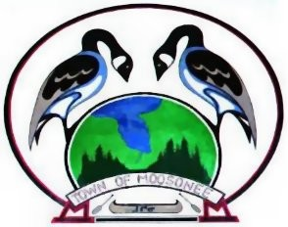
Veolia Water Canada Inc., on behalf of the Town of Moosonee, is committed to supplying a safe, consistent drinking water supply while maintaining strict adherence to all applicable legislative and regulatory requirements. We strive to achieve these goals through the implementation of a management system comprised of policies, procedures, instructions and forms that demonstrate risk-based treatment process, evaluation, staff competency, open communication, workplace safety, and appropriate contingency/emergency response procedures.

Together, the Town of Moosonee and Veolia are committed to:

- Managing and operating the drinking water systems in a responsible manner in accordance with documented quality management policies and procedures.

- Providing the customer with clean, safe drinking water.

- Maintaining and continually improving each quality management system.

- Complying with applicable regulations and legislation

The Town and Operating Authority are committed to accomplishing our goals through the dedication, support and participation of all, and through the maintenance and continual improvement of the Quality Management System.

