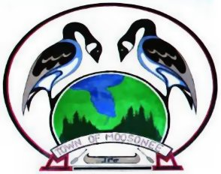Job Posting
Public Works Mechanic
GENERAL DESCRIPTION
Primary responsibility will be to support our maintenance activities in the shop to include, but not limited to:
- diagnose and repair equipment failures/issues
- services such as changing of fluids, filters, etc….
- maintain a clean and safe working environment
- assist in general site related maintenance activities.

RESPONSIBILITIES
- Experienced in repairing large, on-road, construction type equipment in a municipal environment.
- Must be self-starter with the ability to complete diagnostics, troubleshoot and complete repairs to heavy equipment such as, loaders, dump trucks, and pickup trucks, etc.
- Knowledge and experience with diesel and gasoline engines, hydraulic systems and/or electronics preferred.
- Welding and fabrication skills are a plus.
- Must understand technical manuals, illustrations, specifications, diagrams, schematics, and similar guides to make repairs and modifications according to OEM specifications and procedures.

LICENSES / CERTIFICATIONS
Class A Mechanic

Persons interested in this position should submit their resume by
Friday, October 18th, 2019 4:00 p.m.
Trevor Keefe – Public Works Manager
Town of Moosonee, P.O. Box 727
Moosonee, Ontario P0L 1Y0
Email: trevorkeefe@moosonee.ca

Successful Candidate will be required to provide a criminal reference check

In accordance with the Municipal Freedom of Information and Protection of Privacy Act, personal information collected will be used only for the purposes of this employment opportunity. The Town of Moosonee is an equal opportunity employer that is committed to inclusive, barrier-free recruitment and selection processes. Please contact us if you require this posting in an alternate format. If contacted for an interview, please advise if you require accommodation.

We thank all candidates who apply but advise that only those persons selected for an interview will be contacted. Posted October 2nd, 2019

